Getting to know about lunar cycles and how they influence gardening

The ascending and descending Moon
Many people think that an ascending Moon is the same as a waxing one when in fact they are totally different. The Moon ascends and descends over a period of 27 days, 7 hours and 43 minutes, this is called the periodic lunar cycle and is akin to the Sun trajectory’s over a whole year.
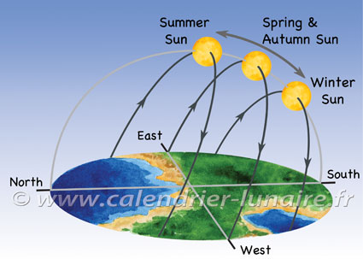
At the end of December (in the northern hemisphere) we see the Sun rise in the south-east to set in the south-west, describing a smallish arc in the sky (at noon, the Sun is fairly low on the horizon). But the following days, all the way to the end of June, it will rise a bit further north every day all the way to the north-east and similarly set further north-west, describing a much larger arc in the sky (at noon the Sun reaches the Zenith). We see the sun rise higher during the first half of the year and then lower in the second half of the year. The Moon has exactly the same course but its cycle last 27 days, 7 hours and 43 minutes.
To resume, the ascending and descending Moon is linked to the movings the moon has in the sky.
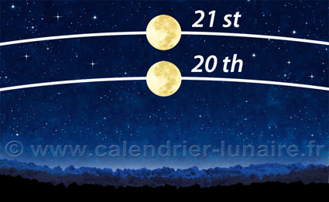
The Moon position on the 20th and the 21st.

Nothern and Southern hemisphere
In the southern hemisphere, the reverse takes place. While in the sky of northern hemisphere we see the Moon ascends, we see the moon descends in the sky of southern hemisphere.
Evidence of its practice dates back to the early civilizations of the Euphrates River valley and it can be found in the folklore of ancient societies all over the world. Roman historian Pliny the Elder wrote about planting by the moon in his History of Nature.

HOW THE MOON INFLUENCES THE GARDEN

Just like how the moon is responsible for tides, the moon has a gravitational pull on the waters in soils, plants, and seeds. The phase of the moon also influences how much light is in the garden. Moon gardening simply involves knowing what phase the moon is in, understanding how that affects the gravity of water, and using that info to know what kind of garden tasks to undertake.

USING THE MOON PHASES TO DETERMINE BEST PLANTING DAYS AND OTHER GARDEN TASKS

THE NEW MOON
Ancient Greeks believed the new moon was a time of fertility and rebirth because the moon and sun were joined together at the same part of the sky. During the new moon, gravity from the moon is pulling water up, which aids in germination. This phase is the best time to plant above ground crops plants that produce seeds outside of the fruit, such as lettuce, spinach, cabbage and grains.

THE FULL MOON
During this phase, energy is drawn down, and after the moon has peaked, the light starts to decrease, good for root growth. Plant root crops such as beets, carrots, onions, and potatoes. This is also a good phase to transplant any type of plant.

WANING MOON (4TH QUARTER)
This is the time of rest and maintenance. Weed, prune, fertilize, and graft during this moon phase. The last few nights of this quarter, when the sky appears moonless, is a fallow period.
This signifies the death of the old before the start of the new. It’s best to do no garden work at this time if possible.

USING THE EARTH’S DAILY CYCLES TO DETERMINE BEST PLANTING DAYS AND OTHER GARDEN TASKS
Some people recognize that the earth has cycles of inhalation and exhalation.
In the morning, Earth exhales, which allows sap and water to rise. This is the best time to harvest plants whose parts we eat are above ground.
Lettuce, for example, is full and plump. This is also the best time to apply foliar feeds and sprays.
In the evening, Earth inhales, which draws sap down into the roots and soil. This is the best time to sow seeds, harvest root crops, dig soil, ready for planting, and spreading compost.

USING THE MOON PATHS TO DETERMINE GARDEN ACTIVITIES
Some gardeners don’t follow the individual moon phases, but instead, take note of the moon’s path and if it’s considered ascending or descending. As the moon orbits around the earth, it moves between the northern and southern elliptical hemispheres. This is also known as the ascending and descending moons.
During the ascending moon, the moon moves above the ellipse and sits high in the sky. On ascending moons, the sap of the plant is drawn up. This is the best time to harvest non-root crops, sow seeds for above ground crops, look out for slugs and other pests, and take cuttings and graft plants.
When the moon is descending, the moon is moving below the ellipse and sits low in the sky. On descending moons, the sap in plants is drawn down. This is a good time to transplant or sow seeds of root crops, weed, feed the soil, prune and mow.

